Nama : Muhammad Naufan Athoillah
NIM : 18106050046
Kelas : B

Screenshot Praktikum 11

- Server

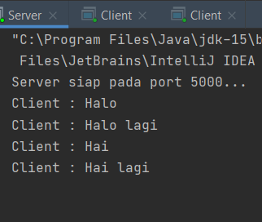

- Client 1

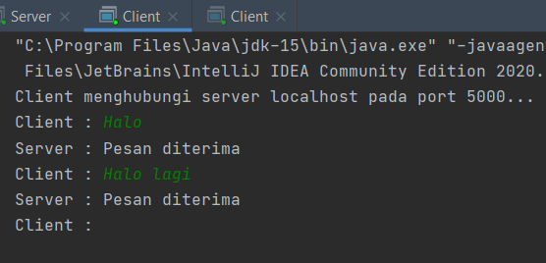

- Client 2



